Professor Marty St James

OUTPUT 4 ***Adagio No.8***

Please view the following video links:

**Output 4/A**

[http://vimeo.com/56525381](http://vimeo.com/56525381" \t "_blank)

**Video Portrait of a Ballet Dancer**

Sitter: Iveta Petrakova – Czech Republic

Music: Roberto Filoseta

also added static images:

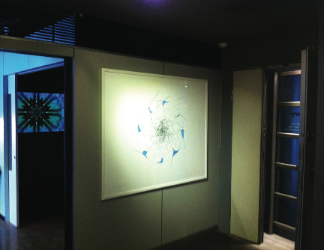

**4/B** Installation view in Taiwan of the video (background) and one of the drawings (foreground)

**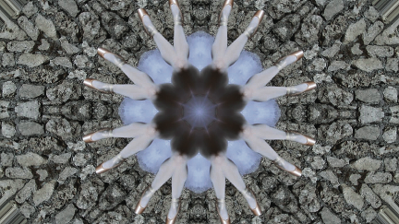**

**4/C** Still from the video portrait Adagio No.8

**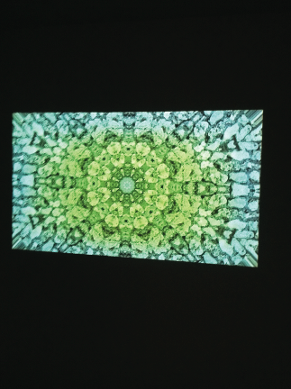**

**4/D** Still shot of the video portrait projected in the gallery

**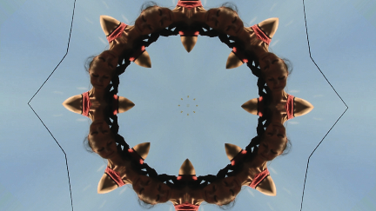**

**4/E** Still from video

**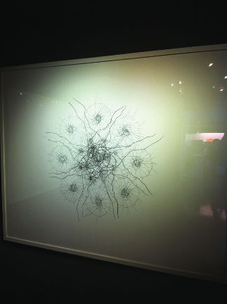**

**4/F** Adagio No.8 drawing no.1 in situ in the gallery (140x122cm)

**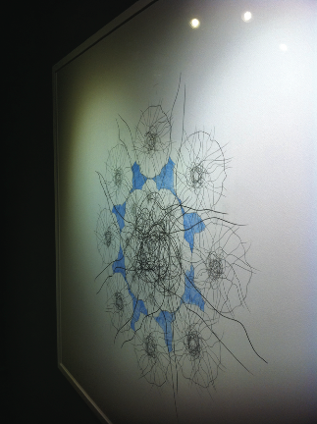**

**4/G** Adagio No.8 drawing no.2 in situ in the gallery (140x122cm)